# IU Verse



# Two women giving thumbs up

Wallpaper this

* [IU on a stool](https://x.com/takashiojiun/status/1892682516726698165?s=46) and a set of New Balance.

# Java File and Uniform Resource Identifier(URI)

[00:10, Java NIO and Path Object] Let me start with the history of Java. The first release of Java 1.0 uses Java AWT

Java utilities, and URL for internet resource. The threading was buggy because it uses the native fork, and the API was system dependent. Back in the days of Symantec, I had a bug where the Java AWT’s Dialog was not showing it. A senior developer finally took a look at my company and found out that my display card did not support the resolution to render the AWT probably.

When Java 1.0.6 came along, some guy who loves to do ballroom swing dancing, creating Java Swing. Eventually that led to latter iterations with Collections that is thread safe and integration with SwingUtilities to have the Swing component to be thread safe.

Java 2 came up with the introduction of Java NIO and URI. URL is deprecated. The whole concept is that Path is the basic concept of a File. It could mean a file in a local hard drive, or a URI. A URI can have multiple directories or Paths. They are loaded using Java’s classloader#GetResourceAsStream for URL or #GetResourceAsFolder for local files.

[1:50, Java NIO and Path Object] You can see on the PepMan’s GTML tab, I’ve rendered a three Book Entry called Book.xml, history/Page_001.xml, and marketing/Page_001.xml into the JEditorPane of GTML tab. Each of the three Path is rendered as shown. They can be thought of as a File in a local hard disk. Eventually the content of the Path is extracted using XPath for xml and getLine into a StringBuffer for .html and display in a PopupGTML which also has a JTree to show the attributes from the extracted information of the .xml file.

[2:45, Java NIO and Path Object] The Properties Panel of GTML only shows the Books attributes (@ tags within the xml file). The PopupFrameGTML shows the JTree and the Books, Chapters, and Pages.

[3:41, Java NIO and Path Object] The **Book Entries** can be rendered after the parser extracts the Java Collections for books in the JTree. A second-level parser is called **Border Line Annotation**. A third-level parser is called **Flatliner**. A **Flatliner** is essentially **Artificial General Intuition** parser. It handles the **Barrier API**  for **Parallel Virtual Machine** Data processing.

[3:53, Java NIO and Path Object] The entire object that gets Trans-Mediated is called a KAR file. It has a manifest information to load up **Book Render**, **Cell Calculator**, and **Cell Prompter**, and **Cube Control**.

[3:59, Java NIO and Path Object] The object in the **Private Realm** is rendered as **Coal Nugget** with the **Private** **Black Nole**. A **Black Nole** passes the **Coal Nugget** into the **Public Realm** as Coal Nugget Media (CNM). A **Public Black** **Nole** takes care of the **Cube Control for Authentication** and **Motion Vector Processing** unit is part of Skyline’s **Artificial General Intuition** using **Kissy Face and Lipstick** interface. The Public Black Nole also handles Barrier API for **Parallel Virtual Machine** for the Public Realm.

[4:50, Java NIO and Path Object] A **Cell Prompter** is the opposite of a **Spreadsheet**. Each cell uses a Postfix Stack based Algebraic Evaluator to evaluate the algebraic expression. It can also be called **Label Algebra**. It will prompt you for the input when the variable is null and not attached to a value for the label. It will be evaluated once the value is attached so the prompt won’t happen again. I had written this to land myself the internship in Symantec. Hey, the lead developer tested it and love it. Here is the sample eval code:

Let $Birthyear = “Please enter your birthyear”;

Let $YearsOld = $Birthday - $NOW

Display(“You are “, ($YearsOld));

Prompt:

Please enter your birthyear: 2000

You are 25 years old.

Here a code for Quadratic Equation:

Let $A = “Enter the value for A of the Quadratic Equation: a^2+bx+c=0”

Let $B = “Enter the value for B of the Quadratic Equation: a^2+bx+c=0”;

Let $C = “Enter the value for C of the Quadratic Equation: a^2+bx+c=0”;

Let $Answer = -b + Square_Root (b^2 – 4ac) /2a

Let $X = Eval($Answer)

Display (“X is” , X);

Prompt:

Please Enter the value for A of the Quadratic Equation: 1

Please Enter the value for B of the Quadratic Equation: 5

Please Enter the value for C of the Quadratic Equation: 6

X is : -2.

With the **Cell Calculator** as spreadsheet, and **Cell Prompter** for general inputs, the **Cube Control** can be added as an entry for a particular cell to the two apps for private and public keys entry.

After the documents are packaged, another **Cube Control** is added to the KAR file. A **Portal** is a very special **3D-Worksheet** of a **Cube**. A **Warp** is a very special **3D**- **Workbook** (the entire document .xls). of a **Cube**. A **Cube Control** for the KAR file is essentially a .xls document in the KAR with the manifest as the pointer).

* [Java NIO and Path Object](https://www.youtube.com/watch?v=zWHgb_0xEwQ)

# SPHEREx

SPHEREx has the answers

* [Jared Issacson and SPHEREx](https://x.com/rookisaacman/status/1899858709565653128)

# IU-glish

* [It's show time as soon as possible](https://x.com/mingukiu/status/1900148498110218367)

# IU’s birthday and Nintendo store

IU’s birthday is May 16th. Nintendo store’s second grand opening is May 15th.

* [Nintendo's second store is back-to-back with IU's birthday](https://x.com/CAgovernor/status/1900256478424162767)

# Andrew Cuomo

* [Gunning to be the new face of New York Major](https://x.com/andrewcuomo/status/1900226969351966991)

# Adam Schiff on Government Shutdown

* [Part 1 of government shutdown](https://x.com/SenAdamSchiff/status/1899990688206336351)

# Measles outbreak

Texas is experiencing the worst measles outbreak in 30 years.

* [Gavin Newsom reposts on measles outbreak](https://x.com/GavinNewsom/status/1899908157117522325)

# Friends and Lovers

Friends help you move.

Lovers help you move dead bodies.

Top politicians steal people’s vote.

Top artist steal people’s time shamelessly.

* [Maggie on Happy International Women's day](https://www.instagram.com/p/DG854OhSs1H/?utm_source=ig_web_copy_link)
* [Louisa Mak](https://www.instagram.com/p/DG7z-0sp8-B/?utm_source=ig_web_copy_link&igsh=MzRlODBiNWFlZA==)

Top politicians drive Tesla to gain attention (so yesteryear)

Top Uber Driver code Poker Face while waiting to steal passenger’s time to exchange for titty squeezes.

* [Live finger code: Poker Face](https://www.instagram.com/reel/CnAeobEqXA-/?utm_source=ig_web_copy_link&igsh=MzRlODBiNWFlZA==)
* [Dear John](https://www.instagram.com/reel/CmAHLgZMzqo/?utm_source=ig_web_copy_link&igsh=MzRlODBiNWFlZA==)
* [Dear John again](https://www.instagram.com/reel/CmBHQx7Lux5/?utm_source=ig_web_copy_link&igsh=MzRlODBiNWFlZA==)

Top badass business guru knows the numbers

* [The road to acquire](https://fb.watch/x_PEN2gncw/?mibextid=wwXIfr)

# Great Lovers

Tim Pool



Figure 1. Tim Pool



Figure 2. Tim Pool.

Lex Fridman



Figure 3. Lex Fridman



Figure 4. Tai Lopez

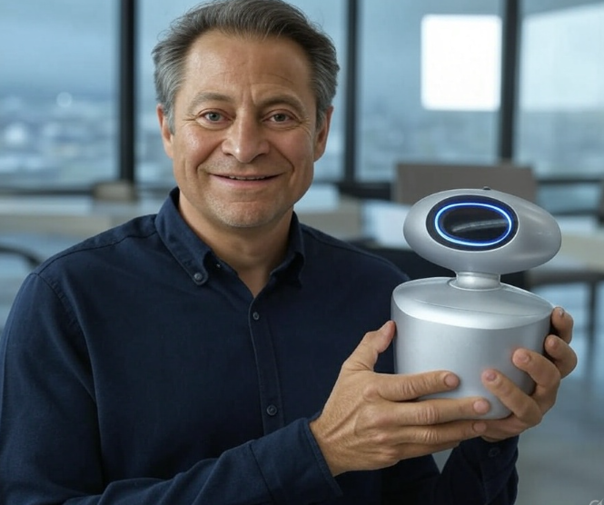

Figure 5. Peter Diamandis holding "AI Phone"

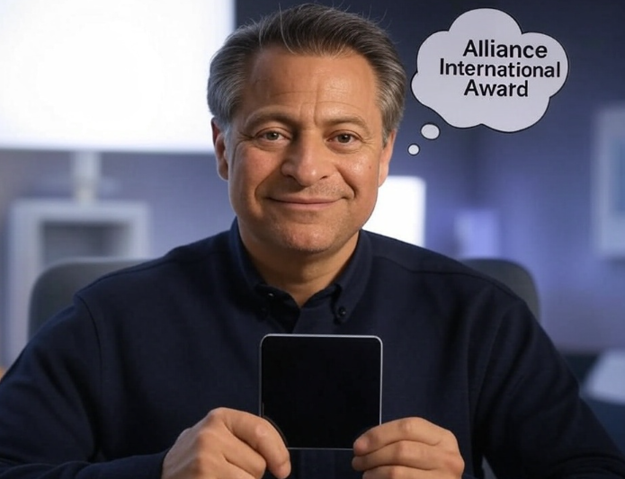

# Email Sender

From Mark Andreesen

* Chris Dixon

[@cdixon](https://x.com/cdixon)

* @eddylazzarin
* @MartinShkreli

Vercel CEO

* @rauch

Spotify CEO: Toby Lutke

* @tobi

Sesame

* @sesame

Brandon Tribe

* @brendaniribe

Aravind Srinivas

* @AravSrinivas

From The View

Donny Osmond

* @donnyosmond

Kara Swisher: Author of Burn Book

* @karaswisher

View Your Deal

* @ViewYourDeal

Adam Glassman

* @TheRealAdamSays

From Chris Williamson

Brigham Buhler

* @ferrisbuhler81

Ronda Patrick

* @foundmyfitness

# The View

* [Wendy Williams](https://x.com/TheView/status/1900290522561843374)

# Andrew Yang

* [With Mark Cuban](https://x.com/AndrewYang/status/1900295575716704522)